👋 Hi everyone, Imran here.
Welcome to Edition #28 of a newsletter that 15,000+ people around the world actually look forward to reading.
We’re living through a strange moment: the internet is drowning in polished AI noise that says nothing.
This isn’t that. You’ll find raw, honest, human insight here, the kind that challenges how you think, not just what you know. Thanks for being part of a community that still values depth over volume.
🎓 Want to up skill in AI?
- Join the next cohort of my Agent Engineering Bootcamp (Developers Edition) April 8
- Watch the free 4-session Agent Bootcamp playlist on YouTube

Running an LLM for every user query is the fastest way to burn budget and add latency. In real-world RAG workloads, users often ask the same thing in slightly different words, yet a naive pipeline still reruns retrieval and regeneration each time. Semantic caching fixes this “always compute” inefficiency by matching queries in embedding space and reusing prior results when the meaning is similar, not the exact text.

Understanding Semantic Caching for RAG Systems
Semantic caching stores and reuses query results based on meaning rather than exact text matches. This approach solves performance problems in LLM applications without sacrificing quality.
Modern semantic cache systems change how you optimize RAG architecture. Traditional caches need identical queries to work. Semantic caches recognize similar questions and serve stored responses. This cuts redundant LLM calls and speeds up your system by up to 300%.
Building a working RAG system is one thing. Scaling it efficiently is another. As query volumes grow and users expect faster responses, you need better caching strategies. Research shows poorly optimized systems waste 60-80% of processing time on redundant operations that semantic caching eliminates.
This guide covers the technical architecture, implementation strategies, and evaluation methods for semantic cache systems. You'll get the practical knowledge needed to transform your RAG performance.

RAG Architecture and Semantic Caching Basics

Core RAG Components
RAG architecture has three main parts: the retrieval system, the augmentation layer, and the generation component. Each part offers opportunities where semantic caching reduces delays.
The retrieval system forms the foundation. Vector databases like Pinecone, Weaviate, or Chroma search through large document collections. This component takes up 40-60% of total system delay. When users submit queries, the system converts them into vector embeddings, searches the knowledge base, and returns relevant document chunks.
The augmentation layer processes retrieved documents. You rank and filter results based on relevance scores and metadata. This stage involves extra LLM calls for reranking and context preparation, adding another 20-30% to total delay. The generation component combines retrieved context with the original query to produce the final response.
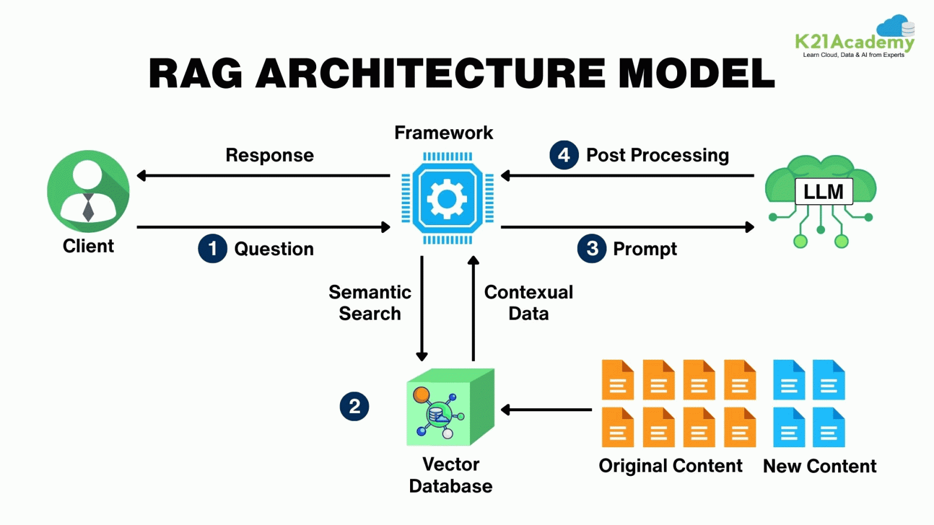
Source : https://habr.com/ru/articles/977260/
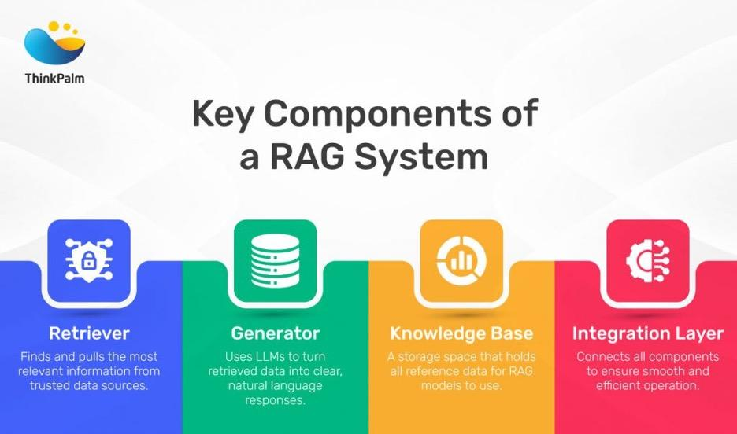
Source: ThinkPalm — https://thinkpalm.com/blogs/what-is-retrieval-augmented-generation-rag/

How Semantic Caching Works with LLMs
Semantic caching recognizes that many user queries share meaning even when worded differently. Traditional caches miss these opportunities because they need exact string matches. For example, "How to optimize database performance?" and "What are the best practices for speeding up SQL queries?" would generate separate cache misses despite asking for similar information.
Semantic caching uses vector embeddings to calculate cosine similarity between queries. This helps the system identify when cached responses work for new but related questions. The approach transforms caching from a binary hit-or-miss system into a nuanced similarity-based retrieval mechanism.
The technology addresses retrieval augmented generation bottlenecks by creating multiple cache layers:
- Query-level caching for similar questions
- Context-level caching for retrieved document chunks
- Response-level caching for generated outputs
Each layer reduces different types of computational overhead while maintaining response quality.
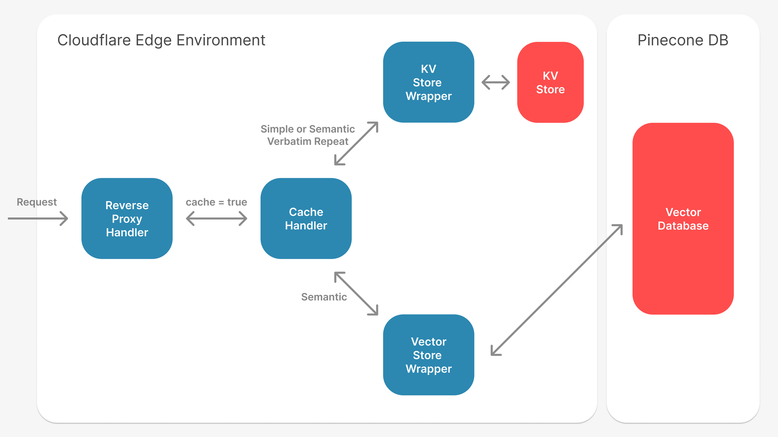
Source: https://portkey.ai/blog/reducing-llm-costs-and-latency-semantic-cache/

Building a Semantic Cache System
Modern semantic cache systems use a multi-layered architecture that integrates with existing RAG components. The primary cache layer sits between the user interface and the retrieval system, intercepting incoming queries and checking for semantically similar cached responses.
The embedding generation component converts new queries into vector representations using the same model employed by the underlying RAG system. This consistency ensures similarity calculations remain accurate. Popular embedding models like OpenAI's text-embedding-ada-002 or Sentence Transformers provide the vector representations needed for effective semantic matching.
Cache storage systems must support high-dimensional vector operations while maintaining fast lookup times. Redis with vector search capabilities, Elasticsearch with dense vector fields, or specialized vector databases serve as the backbone for semantic cache storage. The cache management layer handles similarity threshold enforcement, cache invalidation policies, and performance monitoring.
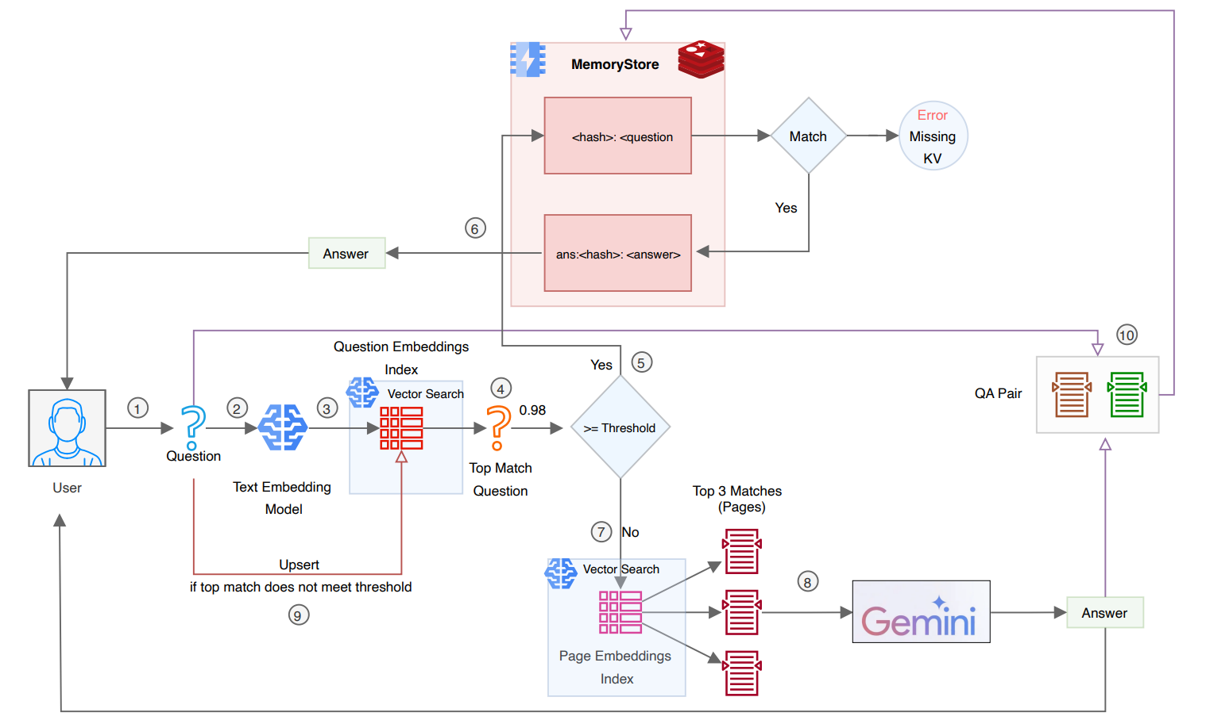
Source: https://medium.com/google-cloud/implementing-semantic-caching-a-step-by-step-guide-to-faster-cost-effective-genai-workflows-ef85d8e72883

Performance Impact of Semantic Caching

Measured Speed Improvements
Production deployments of semantic cache systems show substantial performance improvements. Organizations report 3-5x speed reductions for repeated or similar queries, with cache hit rates ranging from 30-70% depending on use case patterns and similarity threshold settings.
Real-world data shows:
- Customer support chatbots achieve response times of 200-400ms with semantic caching, compared to 1.2-2.5 seconds without
- Knowledge management systems drop from 10-15 seconds to 2-4 seconds when cache hits occur
- Organizations processing 1 million queries monthly see 40-60% reductions in inference costs

Optimizing Cache Hit Rates
Effective evaluation methods reveal optimal similarity thresholds typically range between 0.85-0.95 cosine similarity, depending on domain specificity and acceptable response variation. Lower thresholds increase cache hit rates but risk serving less relevant responses. Higher thresholds maintain quality at the expense of caching effectiveness.
Dynamic threshold adjustment based on query patterns and user feedback enables systems to optimize for specific use cases:
- Customer service applications often benefit from lower thresholds (0.82-0.87) due to repetitive question patterns
- Technical documentation systems require higher thresholds (0.92-0.97) to maintain accuracy
Cache performance monitoring reveals effective systems achieve 45-65% hit rates within the first week of deployment. Rates climb to 60-80% as the cache builds comprehensive coverage of common query patterns. The initial warm-up period typically requires 10,000-50,000 queries depending on domain complexity.

Resource Efficiency
Semantic caching dramatically reduces computational overhead across multiple system components:
- Vector database query loads decrease by 40-70%
- LLM inference costs drop proportionally to cache hit rates, with high-performing systems reducing API calls by 50-80%
- Memory utilization increases by 10-20% for embedding storage and similarity calculations, but this overhead pays dividends through reduced processing requirements
- CPU usage drops significantly during cache hit scenarios
- Network bandwidth consumption decreases as cached responses eliminate external API calls
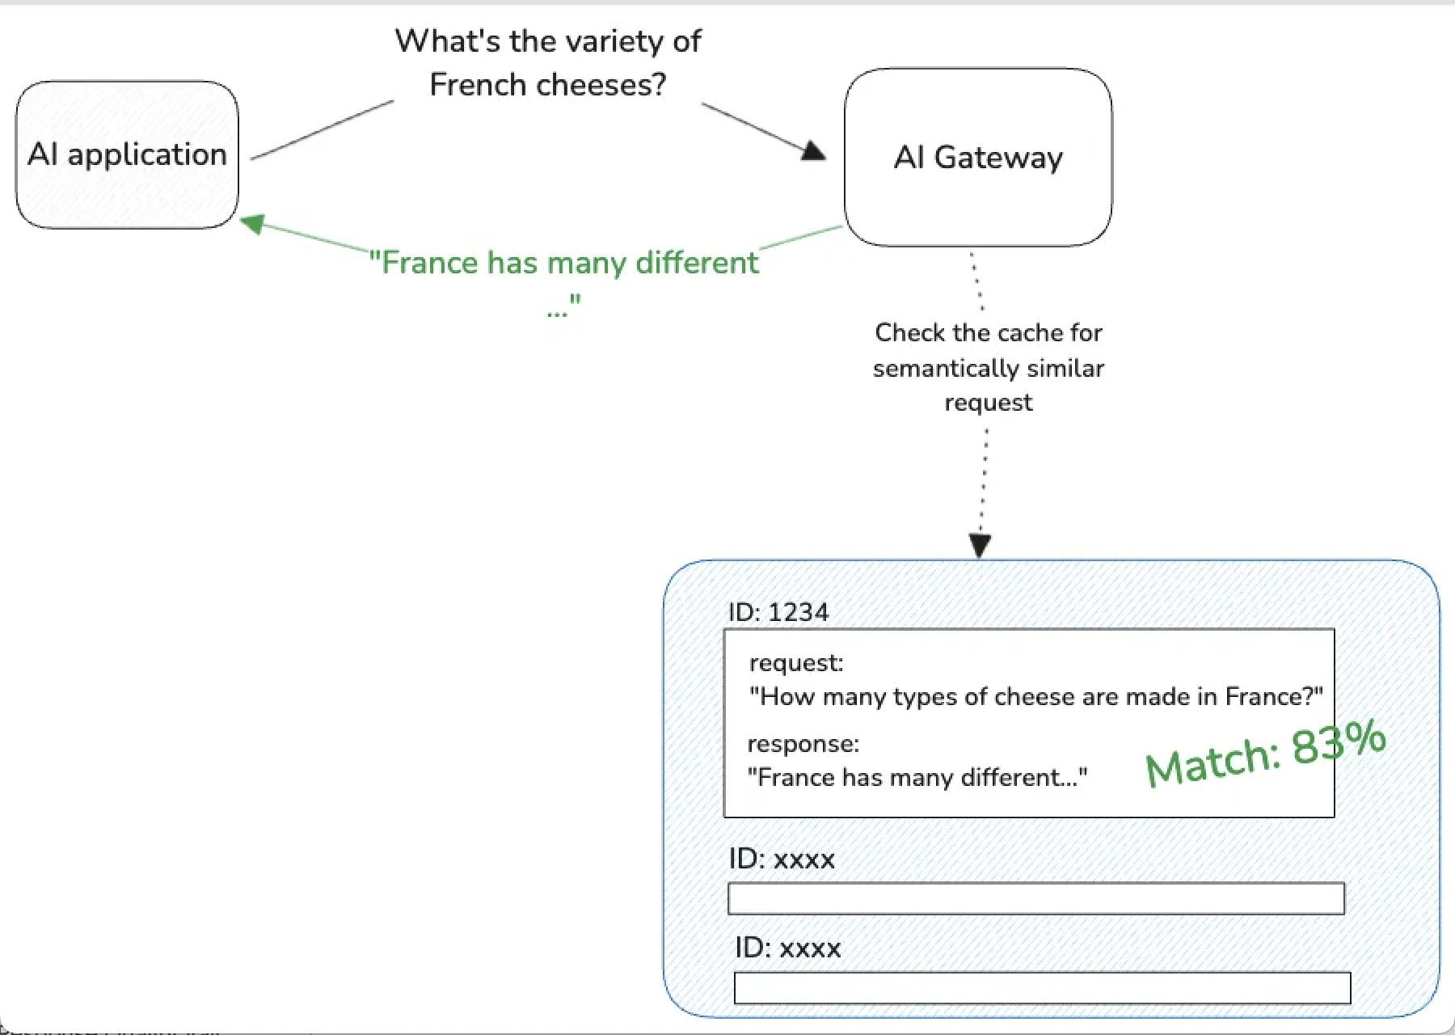
Source: https://www.solo.io/blog/semantic-caching-with-gloo-ai-gateway

Implementation Strategies

Query Preprocessing and Embedding Generation
Start with robust query preprocessing pipelines that normalize input text before embedding generation. Text normalization includes removing extra whitespace, standardizing punctuation, and applying consistent casing rules to ensure semantic similarity calculations remain accurate.
Query expansion techniques improve cache hit rates by identifying synonyms and related terms before embedding generation. This approach requires careful tuning to avoid semantic drift. Production systems often implement lightweight expansion focusing on domain-specific terminology and common abbreviations.
Embedding model selection significantly impacts cache effectiveness. Use the same embedding model for both cache generation and the underlying RAG system to ensure consistency in vector space representation. Organizations deploying multiple RAG systems may benefit from standardizing on a single, high-quality embedding model across all implementations.
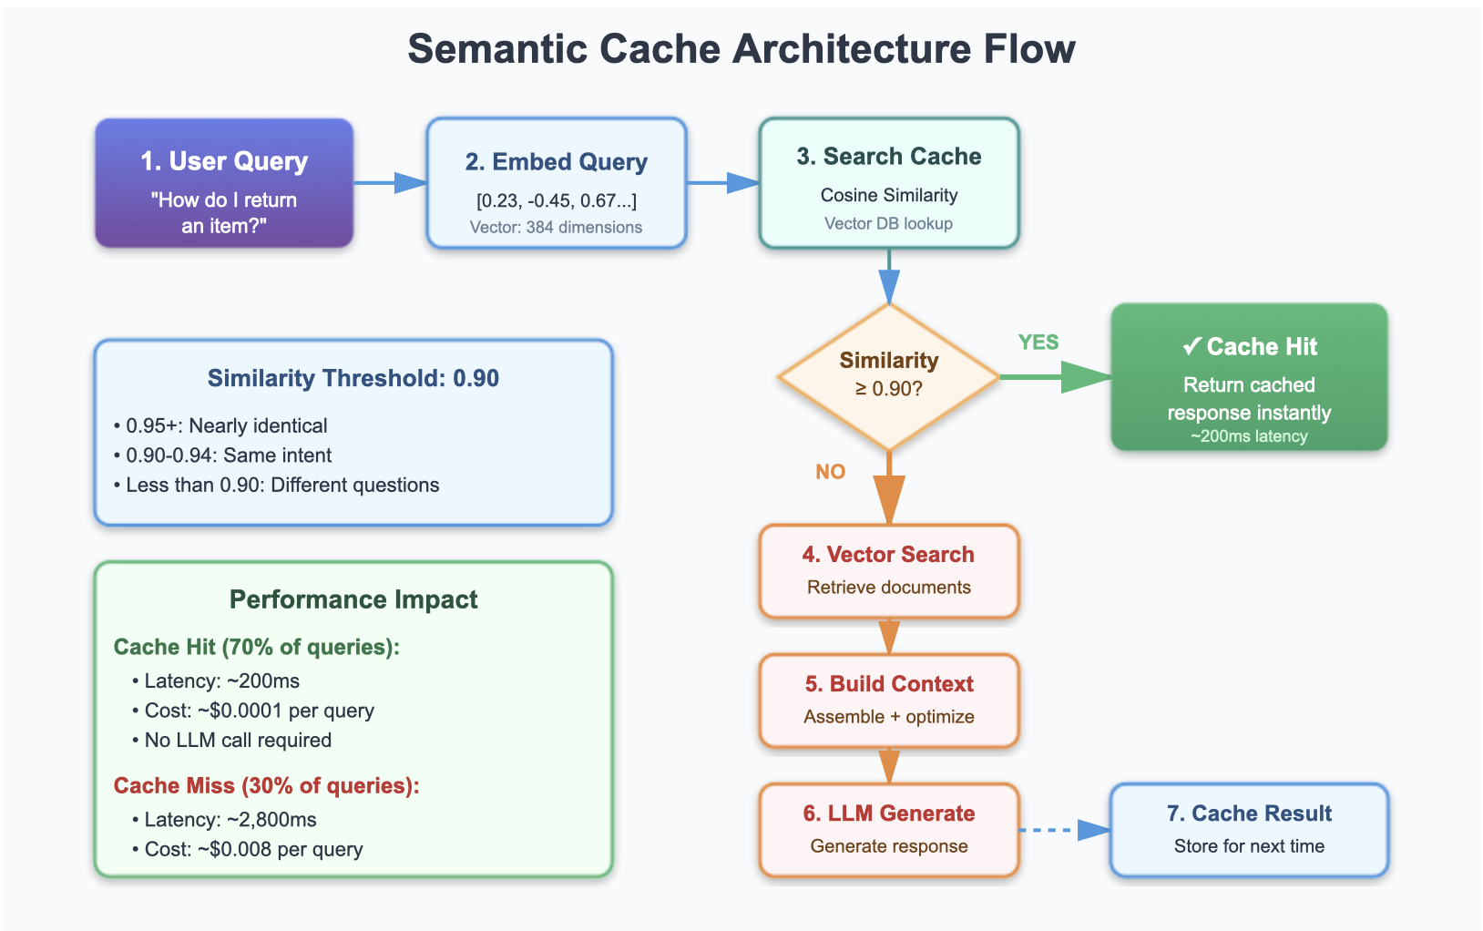
Source:https://www.codebrains.co.in/blog/2025/ai/semantic-cache-smartest-way-to-speed-up-rag

Cache Storage Architecture
Modern cache storage systems require specialized vector indexing capabilities to support fast similarity searches across large cache volumes. RAG implementations typically use approximate nearest neighbor (ANN) algorithms like HNSW (Hierarchical Navigable Small World) or IVF (Inverted File) to balance search accuracy with query performance.
Redis with RedisSearch provides an accessible solution for smaller deployments, supporting vector similarity searches alongside traditional cache operations. The integrated approach simplifies architecture while providing the performance needed for sub-100ms cache lookups.
Larger deployments often implement dedicated vector databases like Pinecone, Weaviate, or Milvus for cache storage. These specialized systems offer advanced features like dynamic indexing, distributed storage, and optimized similarity search algorithms.
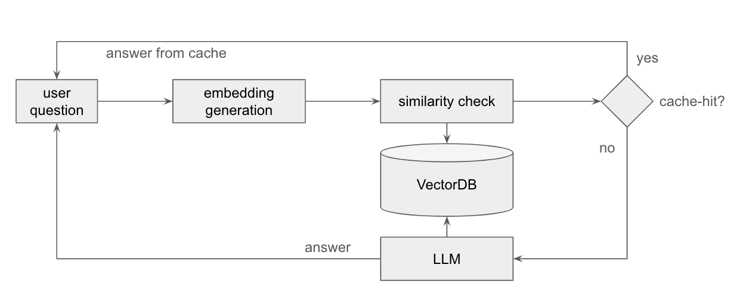
Source:https://www.smartlab.at/unlock-efficiency-slash-costs-and-supercharge-performance-with-semantic-caching-for-your-llm-app/

Cache Invalidation and Freshness
Effective cache invalidation strategies prevent stale information while maximizing cache utility. Time-based expiration provides the simplest approach, with cache entries automatically expiring after predetermined periods. But this method doesn't account for content freshness requirements or query-specific relevance patterns.
Content-aware invalidation monitors underlying knowledge base updates and proactively removes cache entries that reference modified or deleted documents. This approach requires tight integration between the cache system and document management infrastructure but ensures response accuracy as source data evolves.
Advanced implementations use relevance scoring and user feedback to identify cache entries that may no longer provide optimal responses. Entries receiving poor user ratings or low relevance scores face accelerated expiration. Highly-rated cached responses earn extended cache lifetimes.
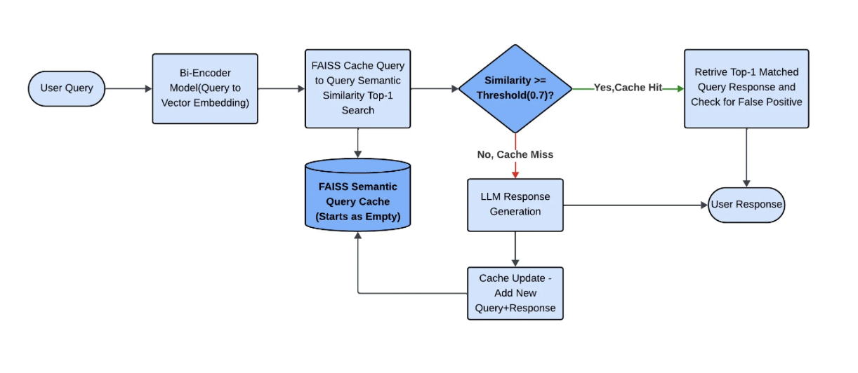
Source:https://www.infoq.com/articles/reducing-false-positives-retrieval-augmented-generation/

Evaluation Methods for Semantic Cache Performance

Cache Hit Rate Analysis
Comprehensive evaluation of semantic cache systems begins with detailed cache hit rate analysis across different query patterns and user behaviors. Effective evaluation tracks hit rates by query category, user segment, and temporal patterns to identify optimization opportunities.
Pattern recognition analysis reveals certain query types benefit more from semantic caching than others:
- Factual queries about specific topics often show high cache hit rates (60-80%)
- Open-ended creative queries demonstrate lower rates (20-40%) due to their diverse nature
Temporal analysis uncovers usage patterns that influence cache effectiveness. Business applications often show cyclical patterns with higher hit rates during peak hours. Educational platforms demonstrate seasonal patterns aligning with academic calendars and course schedules.
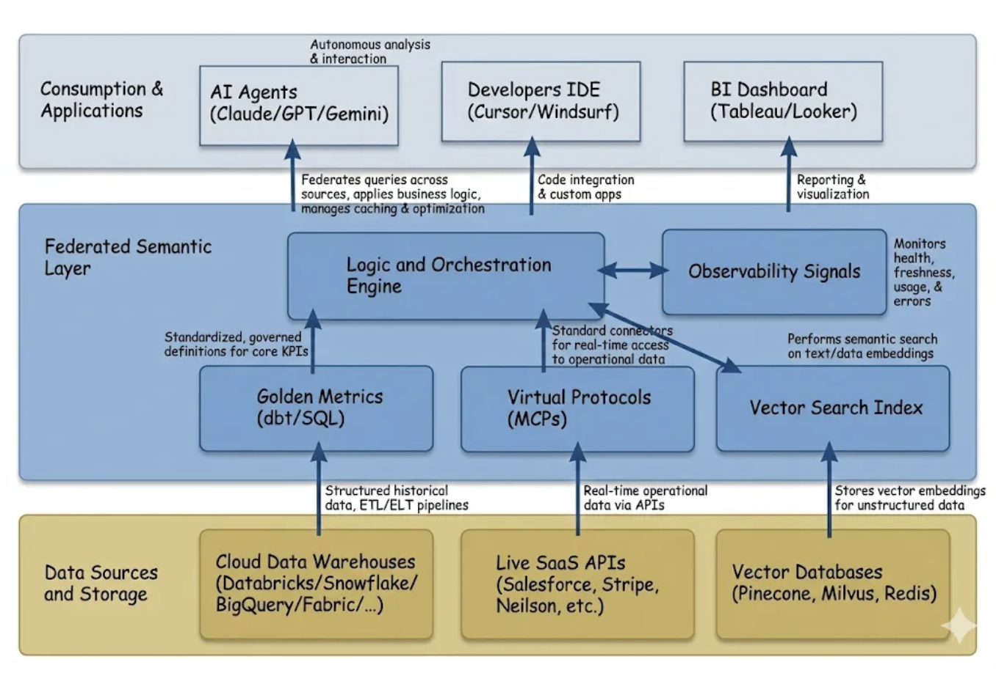
Source:https://tdtapas.medium.com/the-semantic-layer-isnt-dead-it-just-got-a-brain-transplant-4cee5c9b8ebe

Measuring Speed and Performance
Comprehensive evaluation requires speed measurement across multiple system components. End-to-end response time monitoring captures user experience, while component-level measurements identify specific optimization opportunities.
Baseline measurement without caching establishes performance benchmarks for comparison. Production systems should measure speed distributions rather than simple averages. P95 and P99 measurements provide more meaningful insights than mean response times.
A/B testing methodologies enable controlled evaluation of cache configuration changes. Testing different similarity thresholds, cache sizes, and invalidation policies against control groups provides statistical validation of performance improvements. Proper statistical significance testing ensures observed improvements reflect genuine system enhancements.

Response Quality Validation
Semantic cache evaluation must balance performance improvements with response quality maintenance. Speed improvements through caching should never compromise answer accuracy or relevance. Automated relevance scoring using embedding-based similarity between cached and freshly generated responses provides quantitative quality metrics.
Human evaluation protocols establish ground truth for response quality assessment. Expert reviewers rate cached responses on accuracy, relevance, and completeness compared to fresh RAG system outputs. Inter-rater reliability measurements ensure evaluation consistency across multiple reviewers.
User satisfaction metrics provide real-world quality validation:
- Implicit feedback through user interaction patterns (click-through rates, session duration, return visits)
- Explicit feedback (ratings, surveys)
These metrics often prove more valuable than automated quality scores for production system optimization.

Multi-Dimensional Performance Analysis
Advanced evaluation examines semantic cache performance across multiple dimensions simultaneously. Cost-benefit analysis weighs cache infrastructure expenses against reduced LLM API costs and improved user experience metrics. Total cost of ownership calculations include cache storage costs, computational overhead, and system complexity increases.
Scalability analysis projects cache performance under varying load conditions. Stress testing with simulated query volumes reveals performance degradation patterns and identifies system bottlenecks. Load testing should include diverse query patterns that reflect realistic usage scenarios.
Comparative analysis against alternative optimization strategies provides strategic context for semantic caching implementation. Evaluating caching alongside techniques like query optimization, model fine-tuning, or infrastructure scaling helps organizations choose the most cost-effective performance improvement approach.
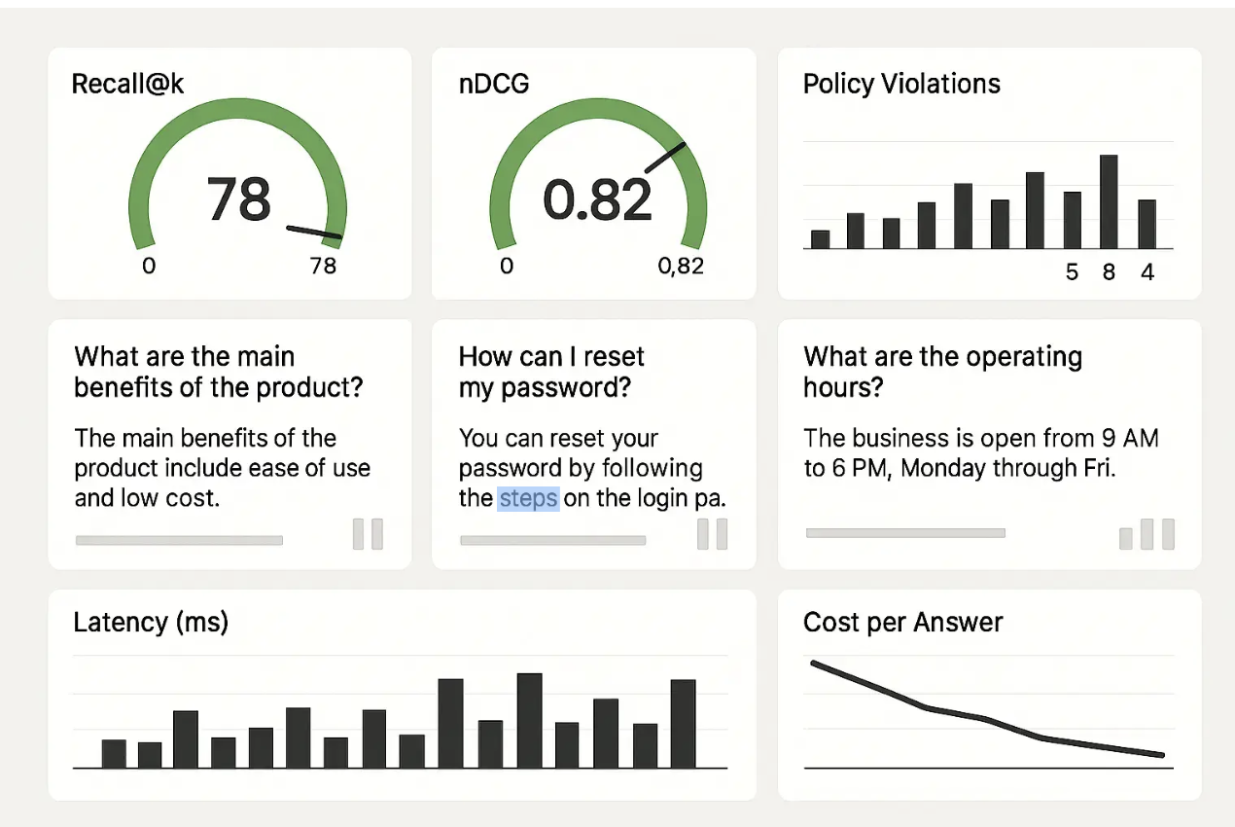
Source:https://ombrulla.com/insights/rag-maturity-model-stages-metrics-anti-patterns

Advanced Implementation Techniques

Multi-Layered Caching Strategies
Enterprise semantic cache deployments benefit from multi-layered caching architectures that address different types of computational overhead:
- First layer implements traditional exact-match caching for identical queries, providing instantaneous responses with zero similarity calculation overhead
- Semantic similarity layer captures near-duplicate queries using vector embeddings and cosine similarity calculations
- Context-level caching stores frequently accessed document chunks and their embeddings to accelerate retrieval operations
- Response component caching stores partial responses and reasoning chains for recombination
This approach proves effective for analytical or multi-step reasoning tasks where portions of the response generation process remain consistent across similar queries.
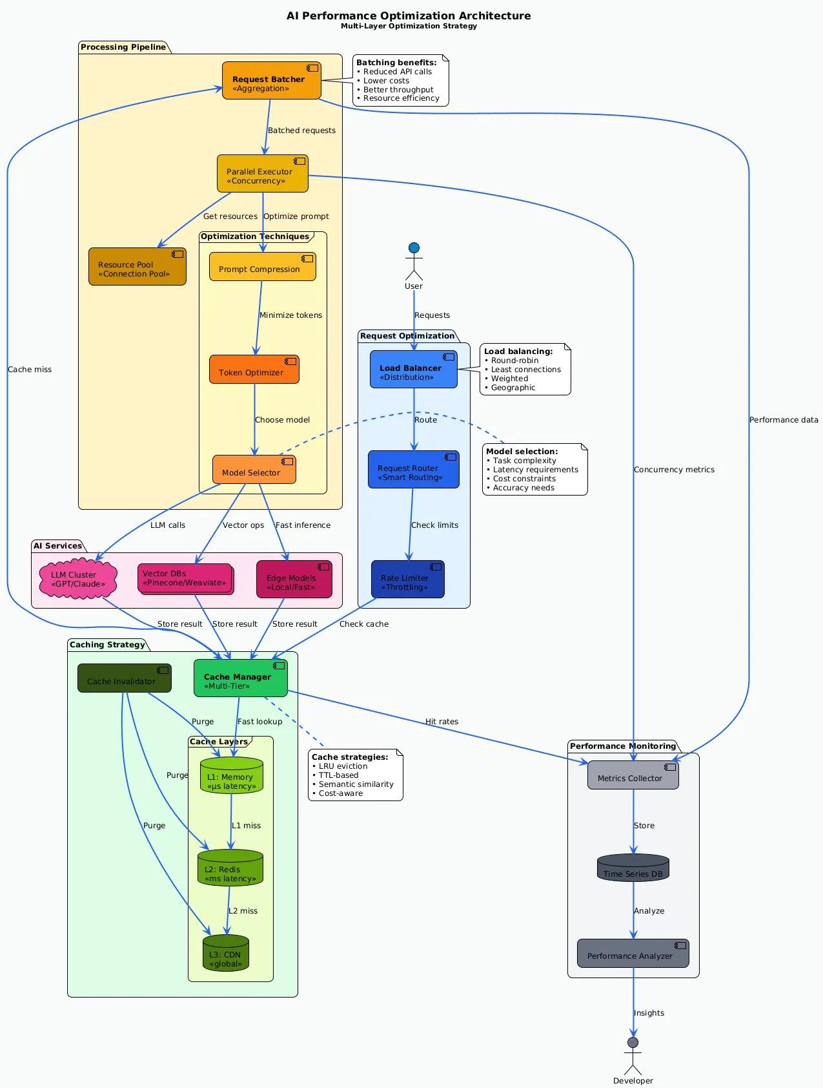

Source:https://medium.com/@omark.k.aly/performance-optimization-scaling-ai-to-production-139502b431c4

Dynamic Threshold Adjustment
Static similarity thresholds fail to account for domain-specific patterns and evolving user behavior. RAG implementations increasingly use dynamic threshold adjustment based on historical performance data and real-time quality metrics. Machine learning algorithms analyze cache hit rates, user satisfaction scores, and response quality measurements to optimize thresholds automatically.
Reinforcement learning approaches treat threshold adjustment as an optimization problem, with rewards based on successful cache hits that maintain quality standards. This approach enables systems to adapt to changing query patterns without manual intervention.
A/B testing frameworks support continuous threshold optimization by comparing different threshold values across user segments. Statistical analysis identifies optimal threshold ranges for specific user types, query categories, and application contexts.

Integration Patterns
Seamless integration with existing RAG architecture requires careful consideration of system interfaces and data flow patterns. Middleware implementations provide the least disruptive integration approach, sitting between client applications and existing RAG systems without requiring architectural changes.
API gateway patterns enable centralized cache management across multiple RAG instances or microservices. This approach simplifies cache administration while providing consistent caching behavior across distributed system architectures. Load balancing considerations ensure cache lookups don't become performance bottlenecks during peak usage periods.
Event-driven architectures support real-time cache invalidation based on data source updates. When underlying documents change, event streams trigger targeted cache cleanup operations, ensuring response freshness without broad cache clearing.
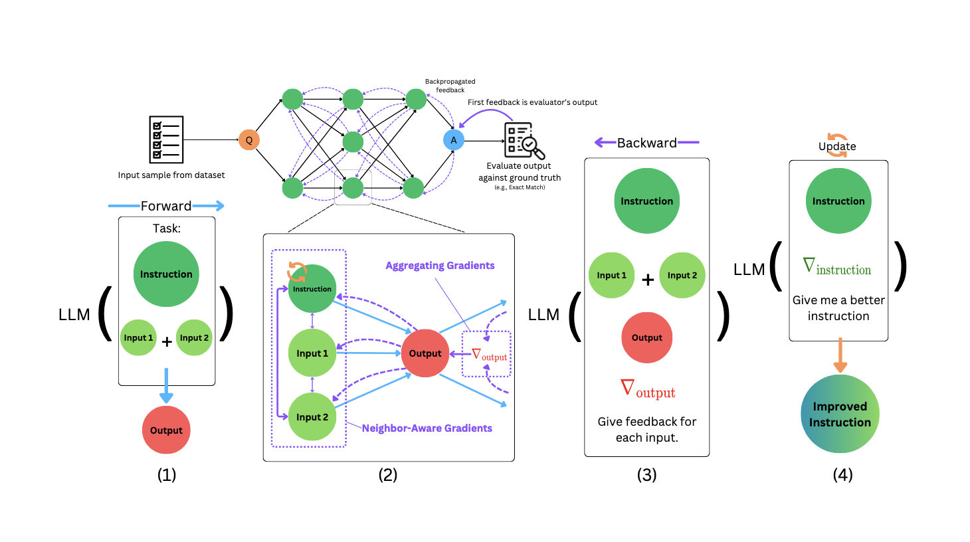
Source:https://www.marktechpost.com/2025/01/08/this-ai-paper-introduces-semantic-backpropagation-and-gradient-descent-advanced-methods-for-optimizing-language-based-agentic-systems/

Performance Monitoring
Production semantic cache systems require comprehensive monitoring to maintain optimal performance and identify issues before they impact user experience. Key performance indicators include:
- Cache hit rates
- Average similarity scores
- Response speed distributions
- Quality metrics derived from user feedback
Real-time dashboards display cache performance metrics alongside system health indicators. Alert systems notify operations teams when cache hit rates drop below expected thresholds, similarity score distributions shift unexpectedly, or quality metrics indicate potential issues.
Log analysis frameworks track query patterns, cache behavior, and system performance over time. Historical trend analysis reveals seasonal patterns, identifies optimization opportunities, and supports capacity planning for cache infrastructure scaling.

Troubleshooting Common Challenges

Cache Consistency and Synchronization
Distributed RAG deployments often encounter cache consistency challenges when multiple cache instances serve different user populations. Cache warming strategies ensure consistent coverage across distributed instances by sharing high-value cache entries and synchronizing invalidation events.
Event sourcing approaches maintain cache consistency by broadcasting cache updates and invalidations across all instances. Message queue systems like Apache Kafka or Redis Streams provide reliable delivery mechanisms for cache synchronization events, ensuring stale data doesn't persist in isolated cache instances.
Conflict resolution strategies address scenarios where different cache instances generate conflicting responses for similar queries. Timestamp-based resolution, consensus mechanisms, or centralized cache authorities provide different approaches to maintaining consistency depending on system requirements.

Memory Management
Semantic cache implementations must balance cache size with memory constraints and system performance. Least Recently Used (LRU) eviction policies provide a starting point, but semantic caches benefit from relevance-based eviction that considers similarity scores and user interaction patterns.
Memory optimization techniques include:
- Embedding compression
- Approximate similarity calculations
- Tiered storage architectures that move less frequently accessed cache entries to cheaper, slower storage systems
- Vector quantization to reduce embedding storage requirements with minimal impact on similarity calculation accuracy
Resource monitoring helps identify memory usage patterns and guides capacity planning decisions. Automated scaling policies adjust cache size based on available memory and performance requirements, ensuring optimal resource utilization across varying load conditions.
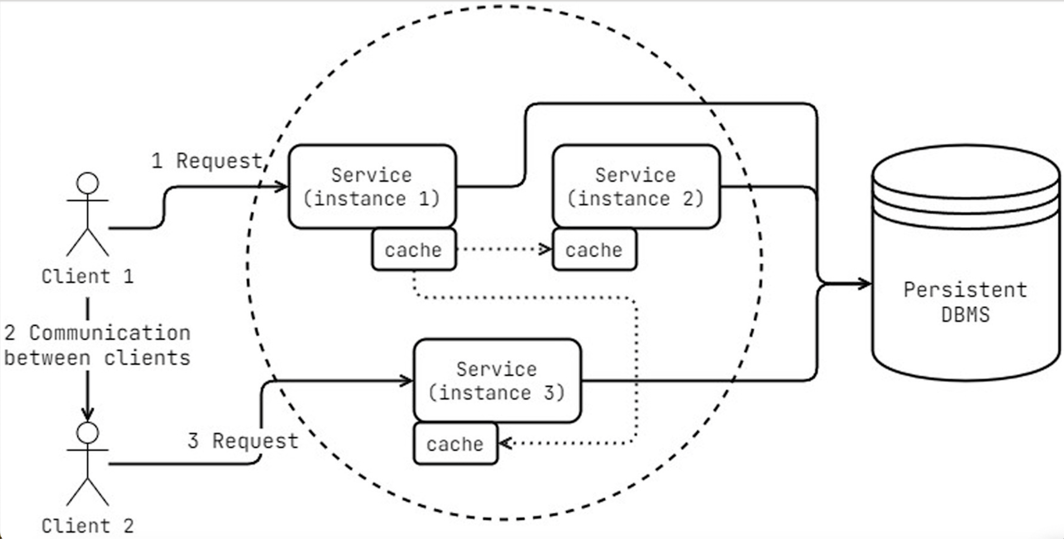
Source:https://www.frontiersin.org/journals/computer-science/articles/10.3389/fcomp.2025.1511161/full

Quality Assurance
Maintaining response quality while maximizing cache utility requires continuous validation processes. Automated quality checks compare cached responses against freshly generated outputs using semantic similarity metrics and structured evaluation frameworks. Significant quality degradation triggers automatic cache invalidation for affected entries.
Human-in-the-loop validation processes supplement automated quality checks with expert review of cached responses. Quality assurance teams regularly sample cached content to identify potential issues before they impact user experience. Feedback loops incorporate quality assessment results into cache management policies.
Response diversification strategies prevent semantic caches from reducing system creativity or introducing bias through repetitive responses. Randomization mechanisms occasionally bypass cache lookups for similar queries, ensuring fresh responses remain available.

Future Trends

Integration with LLM Advances
Emerging developments in large language model architecture create new opportunities for semantic cache optimization. Retrieval-augmented language models with built-in caching capabilities reduce the complexity of external cache management while providing tighter integration between caching and generation processes.
Multi-modal caching extends semantic similarity concepts beyond text to include images, audio, and video content. Vector embeddings that capture cross-modal relationships enable caches to serve relevant responses regardless of input modality, dramatically expanding cache utility for modern AI applications.
Federated learning approaches enable collaborative cache development across organizations while preserving data privacy. Shared semantic understanding improves cache effectiveness for all participants while maintaining confidentiality of proprietary information and user data.

Real-Time Adaptation
Next-generation semantic cache systems incorporate real-time learning capabilities that adapt to changing user patterns and domain knowledge without manual intervention. Online learning algorithms continuously update similarity thresholds, cache prioritization, and invalidation policies based on system performance and user feedback.
Context-aware caching considers user session history, preferences, and behavioral patterns when making cache decisions. Personalized similarity thresholds and cache priorities speed up systems while providing more relevant responses tailored to individual user needs.
Predictive caching uses machine learning models to anticipate future queries and proactively generate cache entries. This approach reduces cache miss rates and improves system responsiveness by preparing responses before users submit queries.

Industry Standards Evolution
The maturation of semantic caching technology drives development of industry standards for cache evaluation, performance measurement, and quality assurance. Standardized metrics enable consistent comparison across different implementations and support vendor-neutral evaluation frameworks.
Open-source semantic cache frameworks democratize access to advanced caching capabilities while fostering community-driven innovation. Collaborative development accelerates feature development and improves system reliability through diverse testing and validation across different use cases.
Regulatory compliance considerations shape semantic cache development as organizations deploy AI systems in regulated industries. Privacy-preserving cache architectures, audit trail requirements, and data retention policies influence system design and implementation approaches.

Reflections
Semantic caching for LLMs transforms RAG architecture optimization and delivers measurable performance improvements while maintaining response quality. Through intelligent similarity-based caching, organizations achieve 3x speed reductions, 40-60% cost savings, and dramatically improved user experience across diverse application domains.
The implementation strategies in this guide provide a comprehensive framework for deploying semantic caching systems that scale effectively with growing query volumes and evolving user requirements. From basic Redis-based implementations to sophisticated multi-layered architectures, the technical approaches adapt to various organizational needs and infrastructure constraints.
Comprehensive evaluation methods ensure performance improvements don't compromise response quality or user satisfaction. Monitoring, quality validation, and continuous optimization processes maintain optimal cache performance while adapting to changing patterns and requirements. The future of semantic caching promises even greater integration with advancing LLM technologies, real-time adaptation capabilities, and industry-standard evaluation frameworks.

Did you enjoy this post? Here are some other AI Agents posts you might have missed:
KV Caching and Speculative Decoding

A deep dive into Quantization: Key to Open Source LLM Deployments

Agents are here and they are staying

How Agents Think

Memory – The Agent’s Brain

Agentic RAG Ecosystem

Multimodal Agents

Scaling Agents: Architectures with Google ADK, A2A, and MCP

Fully Functional Agent Loop

Ready to take it to the next level?
Check out my AI Agents for Enterprise course on Maven and be a part of something bigger and join hundreds of builders to develop enterprise level agents.

Use this link to get $201 OFF!
You’re receiving this email because you’re part of our mailing list—and you’ve attended, registered for, or been invited to our MAVEN events. These emails are the only way to reliably receive updates from us. We don’t spam or sell your information. If you prefer not to receive our messages, simply unsubscribe below and we’ll respect your wishes.

